Do you want to elevate
your game?

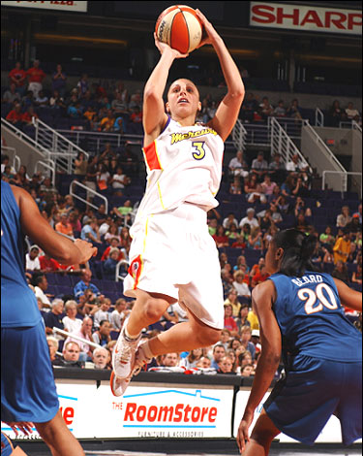

If you want a better game next fall you better
plan ahead and working on it TODAY.
Great athletes consider the cost and prepare!

Open gyms, weight room, video training, checking out DVD’s. You have the opportunity, but what will you do with it? Don’t wait and end up with the same old game. Energize It!

Yourschool Basketball Rocks!

